Specifications

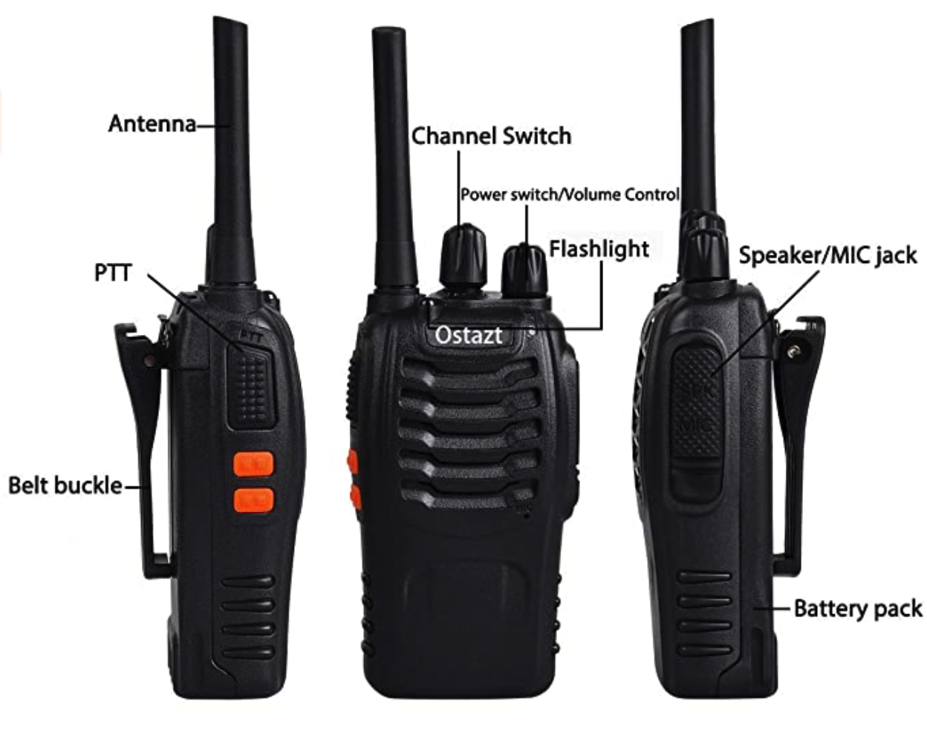

Table of Contents
General 3
Gallery 4

General

Name | BF-88E
Brand | Baofeng
Release Date
Wattage | 0.5W
Frequency Range | PMR446MHz
Battery | DC3.7V 1500mAh
Channels | 16

Gallery

Description | Image
Details | 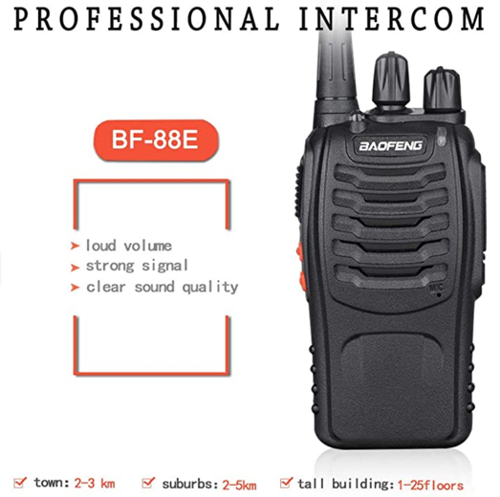
Dimensions Diagonal | 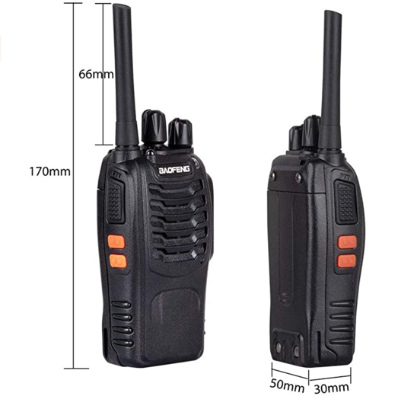
Front and Sides with Labels | 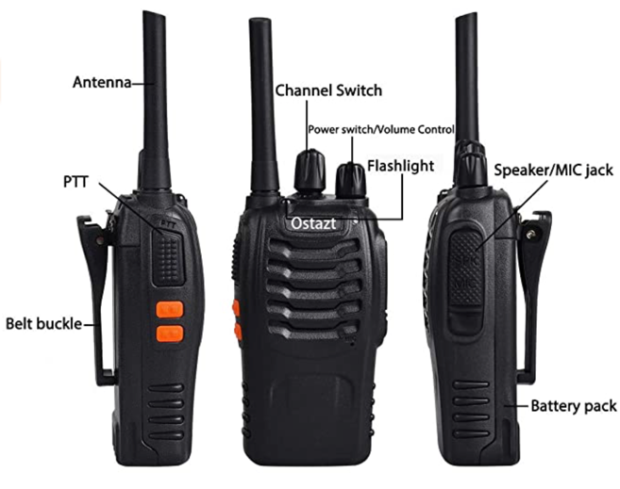
General Multifunction | 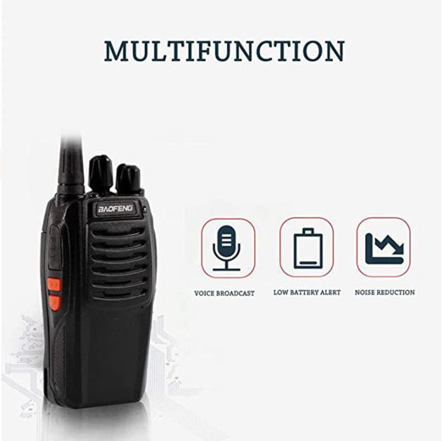
Headphones | 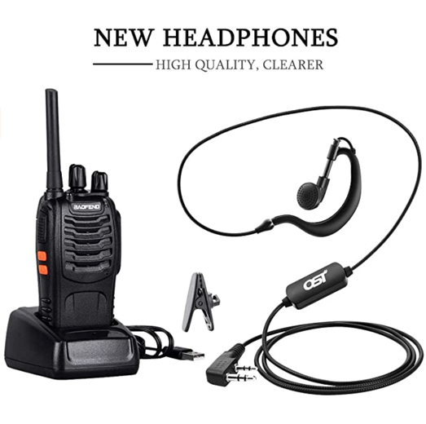
Package List | 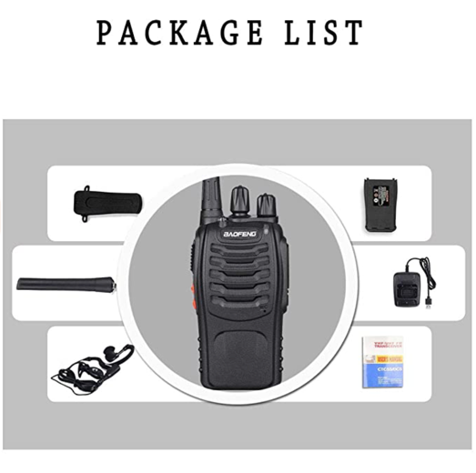
Two Radios and Docks | 